# Who is Brighter Teaching

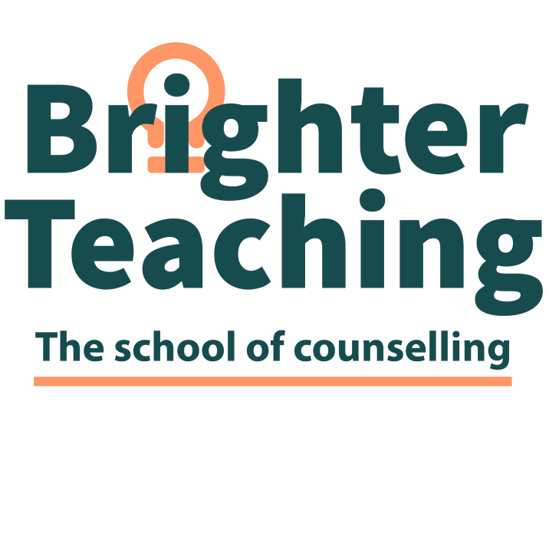

**Level 6 Certiﬁcate in Clinical Therapeutic Supervision**

Brighter Teaching is an independent education organisation that specialises in teaching counselling theory and practice. We are dedicated to empowering our students to achieve their best through educational attainment and self-growth. We strongly believe in each student's potential and strive to empower them to succeed and reach their full potential.

Brighter Teaching offers highly qualified, experienced, passionate professionals in counseling, including tutors, counsellors, supervisors, and health & social care practitioners who are eager to share their knowledge and experience with you. We understand the dedication and commitment it takes to grow and flourish, and we provide a supportive environment to make this happen.

Brighter Teaching is dedicated to offering a place of learning that is accepting, inclusive, and promotes equality and diversity. We believe our learners should be at the very heart of the organization, and we are unwavering in our commitment to empowering both students and staff to find their voice and be impassioned, motivated, courageous, and creative.

# Who are Crossﬁelds Institute

The course is fully accredited by the Crossﬁeld Institute Awarding Body. The Crossﬁeld Institute is a registered charity founded in 2007; their philosophy fully aligns with that of Brighter Teaching.

# What do you mean, your qualiﬁcation is Ofqual regulated

# The Oﬃce of Qualiﬁcations and Examinations Regulation (Ofqual) regulates qualiﬁcations, examinations and assessments in England. It oversees the correct functioning and conduct of awarding organisations and the quality of the certiﬁcation they oﬀer.

# Who is it for?

# This qualiﬁcation is designed for people who are counsellors and wish to progress to the role of counselling supervisor.

# What does the qualiﬁcation cover?

You must complete 3 mandatory units/modules:

Supervisory models, roles and responsibilities Supervisory practice (Placement)

Reﬂective practitioner

# Course length

12 months part-time, with 40 hours of practice, working as an allocated supervisee. Learners must complete 1.5 hours of supervision with a maximum of 4 supervisees over 7 months.

# Will I gain any qualiﬁcations?

You will gain an Ofqual regulated Level 6 Certiﬁcate in Clinical Therapeutic Supervision.

# Do I need any knowledge, skills, or qualiﬁcations?

You need to hold a level 4/5 in counselling or have completed and be in a therapeutic supervision role.

i.e. psychology or nursing.

To be eligible to complete the L6, you must have completed at least 450 hours of counselling practice. We will need a supporting email from your supervisor outlining your engagement in regular supervision and readiness to become a supervisor. Email needs to be sent to [tommy@brighterteaching.co.uk](mailto:tommy@brighterteaching.co.uk)

# How will I learn?

You will be taught and supported by a tutor(s). You are expected to attend 80% of the course. Students learn from presentations and skills sessions by building a portfolio of evidence and completing speciﬁc tasks with the guidance of their tutor. The qualiﬁcation is online.

# What materials or equipment will I need to provide?

# The most important resource you will have is your willingness to learn. You should also have a supply

of pens and paper. A good internet connection and being okay with cameras being on at all times are also important.

# Your commitments as a learner

To achieve success on the course, you will need to:

Attend regularly. Please let us know if you need to miss a session. Have suﬃcient time for self-study and completion of homework. Complete the course.

Complete all the assessments. Take part in the activities

Attend supervision while on the course. (SOS)

# Fees

The cost of level 6 changes according to the changes to the awarding body's fees. Brighter Teaching fees are competitive. We cannot offer funding or access to 24+ learner loans, but we have flexible payment plans to spread the costs over the year.

# Progression

On complication of the Level 6 Certiﬁcate in Clinical Therapeutic Supervision. You will able to work as a therapeutic clinical supervisor.

**If you wish to know more you can contact**

[www.brighterteaching.co.uk](http://www.brighterteaching.co.uk/) [info@brighterteaching.co.uk](mailto:info@brighterteaching.co.uk)